DATE: 22.03.2019
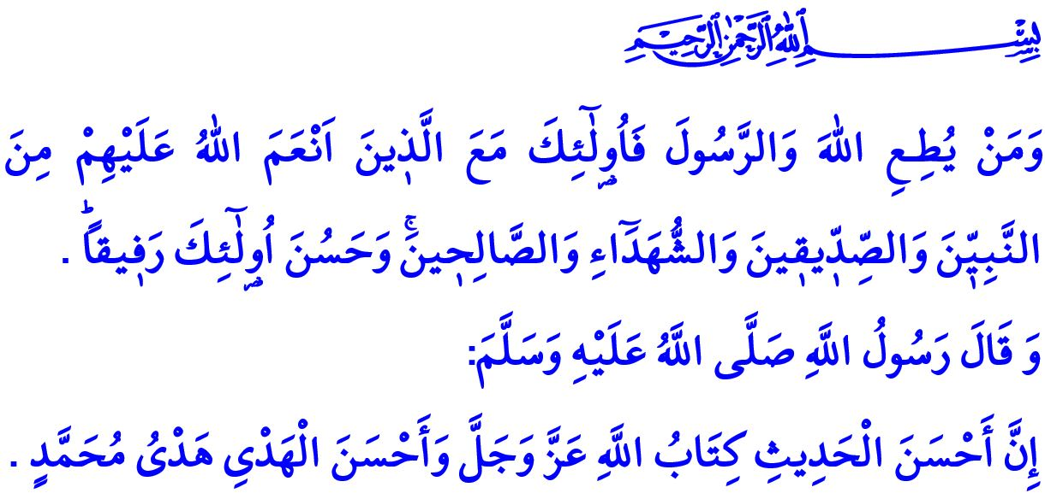
THE QURAN AND THE SUNNAH ARE AN INSEPARABLE WHOLE
Dear Muslims!
The Almighty Allah (swt) states, “And whoever obeys Allah and the Messenger –those will be with the ones upon whom Allah has bestowed favor of the prophets, the steadfast affirmers of truth, the martyrs and the righteous. And excellent are those as companions!”
In this respect, the Prophet Muhammad (saw) says, “The truest word is the Book of Allah and the best guidance is the guidance of Muhammad.”
Honorable Believers!
Allah the Most Merciful (swt) has not left humans alone and unaided in the world. He (swt) has sent prophets to show His servants the right path, and divine books to guide them to salvation. The duty of prophethood that started with the first human and the Prophet Adam ended with the Last Prophet Muhammad Mustafa (saw). The divine message that started to be revealed with the Prophet Adam was crowned by the Holy Qur’an revealed to the Prophet Muhammad (saw).
Honorable Muslims!
The Holy Qur’an is the final divine appeal by Allah (swt) to all people. It is the words and verses of the Almighty Allah (swt). It is the Book, reading which is a form of worship. It is al-Furqan to distinguish the truth from the falsity, the right from the wrong, and the halal from the haram. It is therapeutic for body and soul, and the source of remedy for moral diseases. It is the guide that shows the ways of attaining happiness in this world and in the Hereafter. It is the remembrance that remind people of the purpose of creation.
Dear Believers!
The Sunnah is the compilation of the Prophet Muhammad (saw)’s lifestyle, words, acts, and approvals. While the Qur’an enjoins people to have faith in Allah (swt) and be in servitude to Him (swt) only, the Sunnah teaches people the verities of the faith. While the Qur’an enjoins people to worship as required by the faith, the Sunnah indicates how to perform the worships. While the Qur’an enjoins people to have good morals, the Sunnah functions as the model for such a virtuous life.
Dear Muslims!
Not only did the Prophet Muhammad (saw) conveyed the revelations to him (saw) by the Lord of the Worlds (swt), but he (saw) also clarified them to people. His distinguished life is the best is the best example for us to become good Muslims and lead a life as approved by Allah (swt). If we want to attain peace in this temporary life on earth and in the eternal life in the Hereafter, the only way is to follow the Sunnah of the Prophet Muhammad, and exert efforts to live, think, and behave the way he (saw) did. In this respect, Allah (swt) states, “There has certainly been for you in the Messenger of Allah an excellent pattern for anyone whose hope is Allah and the Last Day and [who] remembers Allah often.”

Honorable Believers!
The Prophet Muhammad lived a life under the custody of the Almighty Allah (swt), Who tasked him (saw) with the duty of prophethood, and was immediately warned by Him (swt) when he (saw) as a human being made even a small mistake. According to the Qur’an, he (saw) never said any word arising out of his own self, but only said what was revealed to him (saw). His Companions carefully observed his blessed words and behaviors, and meticulously transferred them to the future generations.
The Holy Qur’an and the Sunnah unite an inseparable whole. It is not possible to think of the Holy Qur’an that is the foundation of Islam as separate from the Sunnah of the Prophet Muhammad (saw). Trying to put a distance between the Holy Qur’an and the Sunnah, undervaluing the place of the Sunnah in Islam by claiming “The Holy Qur’an is sufficient for us”, and raising doubts about the authentic knowledge passed down on to us from the Prophet Muhammad (saw) are all far from well-intended endeavors that place a heavy burden on a person, because the traditions of the Muslim communities that have faith in the Holy Qur’an have been kneaded with the Sunnah, and the foundations of the Islamic civilization have been laid upon the Holy Qur’an and the Sunnah. In this respect, the Prophet Muhammad (saw) said in the Farewell Sermon (Khutbah al-Wada), “I leave behind me two things, the Quran and my example, the Sunnah and if you follow these you will never go astray”
Dear Muslims!
Then, let us hold on tightly to the Holy Qur’an, and, as it commands, follow the Sunnah of the Prophet Muhammad (saw). Let us not leave from the guidance of the Holy Qur’an and the Sunnah of the Prophet Muhammad (saw). Let us be wary against those people who pave the way for the exploitation of religion and attempt to derive fame and benefit through distancing the Qur’an from the Sunnah. Let us never respect such mindsets claiming that the entire hadith works transmitting the Sunnah to our day is not reliable. Let us be wary also against those people who exploit the sahih (authentic) Sunnah with the words and superstitions that do not belong to the Prophet Muhammad (saw). Let us exert all efforts to raise generations that align their lives with Allah (swt)’s divine revelation, the Holy Qur’an, and the Prophet Muhammad (saw)’s distinguished Sunnah.

Nisa, 4/69.
Nasai, Îdayn, 22.
Ahzab, 33/21.
Najm, 53/3-4.
Muvatta’, Qadar, 3. General Directorate of Religious Services

